PUTNAM UNIFORM DRESS CODE

2023-2024

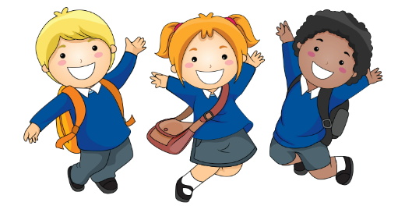

Putnam School has a mandatory uniform policy. The use of school uniforms was established to improve self-esteem, bridge socio-economic differences, promote positive behavior, enhance school safety and provide parents and students with convenient and appropriate school attire at a low cost. Parents who object to their child wearing a school uniform must file a written petition with the principal. The petition must be based on sound philosophical or religious objections. The building principal will approve or disapprove all requests.

The District expects students to come to school in clothes that are clean and that will not be a health or safety threat to themselves or to other students or staff. The District prohibits any clothing or grooming that in the Principal’s/designee judgment, may reasonably be expected to cause disruption of or interference with normal school operations. Tattoos, colored hair, Mohawks, make-up, and excessive jewelry are considered a distraction and not allowed at Putnam.

**Putnam Uniforms:**

Shirts:

Polo Shirts: Long or Short sleeves

Colors: White, Dark Green or Golden Yellow

Sweat T-shirts in White, Dark Green or Golden Yellow

Putnam spirit T-shirts may be worn (STUCO, Field Day and Braden Aboud)

***Students in second-fifth grades must keep their shirts tucked in.***

**Pants:**

Color: Beige khakis, 5 pocket style blue jeans

Style: Regular straight leg

Waist: All waistbands must fit

Length: Shorts, dress jumpers, skirts and skorts must fall below the extended arm and fingertips, but not below the knees.

During the winter, solid white, dark green or golden yellow sweat t-shirts may be worn over the approved Polo style shirts. Students may not wear non-uniform colors or hoodies inside during the winter.

**Types of clothing not allowed**

Wide-leg (bell bottoms), skinny jeans, blue jean Capri pants, baggy, camouflage, cargo or carpenter style pants or shorts. ***Where to purchase uniforms****-*TARGET, SEARS, WALMART, ACADEMY

**Uniform bank**

Do you have children who have outgrown their uniforms? Consider donating them to the Uniform bank. If you wish to donate old uniforms, bring them to the nurse. The donations will be available to families requiring assistance. Thank you.